**Ideation Phase**

**Brainstorm & Idea Prioritization Template**

|  |  |
| --- | --- |
| Date | 20 August 2025 |
| Team ID |  |
| Project Name | shopeEZ One-Stop Shop For Online Purchases |
| Maximum Marks | 4 Marks |

**Brainstorm & Idea Prioritization Template:**

1. Problem Statement: (e.g., Delayed deliveries, poor customer support, etc.)

2. Ideas:

- Improve logistics and shipping processes

- Implement real-time tracking and updates

- Enhance customer support team and response times

- Offer flexible delivery options (e.g., express shipping, scheduled delivery)

- Provide clearer communication about delivery times and expectations

- ...

3. Additional Ideas:

- (Open section for additional ideas to be added)

Prioritization Section:

Idea impact feasibility urgency priority

Improve logistics and shipping processes High Medium High High

Implement real-time tracking and updates Medium High Medium Medium

Enhance customer support team and response times High Medium High High

Offer flexible delivery options Medium Medium Low Medium

Provide clearer communication about delivery times and expectations Low High Medium Low

Prioritization Criteria:

- Impact: How much will this idea improve the customer experience or solve the problem? (High, Medium, Low)

- Feasibility: How easy or difficult is it to implement this idea? (High, Medium, Low)

- Urgency: How quickly does this idea need to be implemented? (High, Medium, Low)

Next Steps:

1. Top Priority Ideas: (List the top 2-3 ideas with the highest priority)

2. Action Plan: (Outline the steps needed to implement the top priority ideas)

3. Responsible Team Members: (Assign team members to lead the implementation of each idea)

This template can help shopEZ generate and prioritize ideas to address specific problems, and create a clear plan for implementation.

**Step-2: Brainstorm, Idea Listing and Grouping**

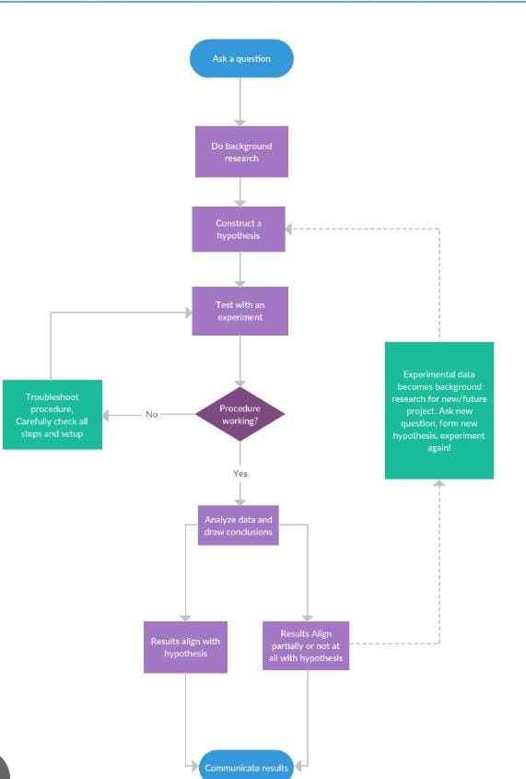

**Step-3: Idea Prioritization**

1. Improve Product Search

- Implement more accurate and relevant search results

- Provide filters and sorting options

2. Enhance Product Information

- Add more detailed product descriptions

- Include high-quality product images

3. Improve Customer Support

- Enhance customer support team and response times

- Offer multiple support channels (e.g., email, phone, chat)

### Phase 2: Streamline Logistics and Shipping

1. Improve Logistics and Shipping Processes

- Partner with reliable shipping providers

- Implement efficient packaging and shipping procedures

2. Implement Real-Time Tracking and Updates

- Provide real-time tracking information

- Send regular updates on shipment status

### Phase 3: Increase Customer Engagement

1. Implement Personalized Recommendations

- Use data analytics to provide personalized product recommendations

- Offer tailored promotions and discounts

2. Enhance User Experience

- Improve website and mobile app usability

- Add features to facilitate easy returns and exchanges

### Phase 4: Monitor and Optimize

1. Track Key Performance Indicators (KPIs)

- Monitor sales, customer satisfaction, and retention rates

- Analyze data to identify areas for improvement

2. Continuously Optimize and Improve

- Gather customer feedback and implement changes

- Stay up-to-date with industry trends and best practices

This flow chart groups ideas into phases, focusing on enhancing customer experience, streamlining logistics and shipping, increasing customer engagement, and monitoring and optimizing performance. By following this flow chart, shopEZ can develop a comprehensive plan to improve its services and increase customer satisfaction.

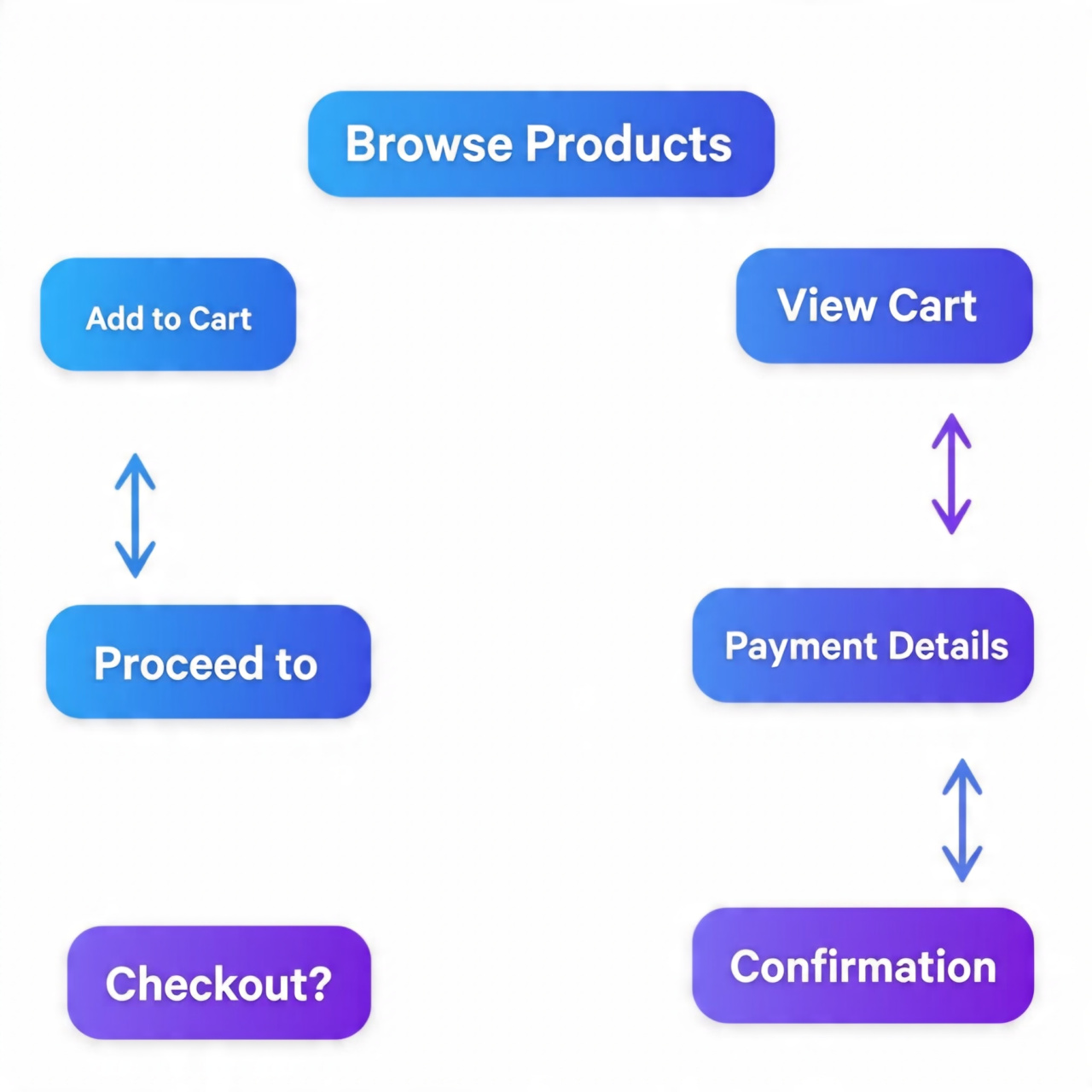

**4.prioritise:**

- Browse Products: The first step in the online shopping process, where customers explore available products.

- Add to Cart: After selecting a product, customers add it to their virtual cart for potential purchase.

- View Cart: Customers can review the items in their cart before proceeding.

- Proceed to: This step likely leads to the checkout process, although the exact action is not specified.

- Payment Details: Customers enter their payment information to complete the purchase.

- Checkout?: A confirmation step before finalizing the transaction.

- Confirmation: The final step, where customers receive confirmation of their purchase.